2015 Meeting: California Student Chapter of the Marine Mammal Society

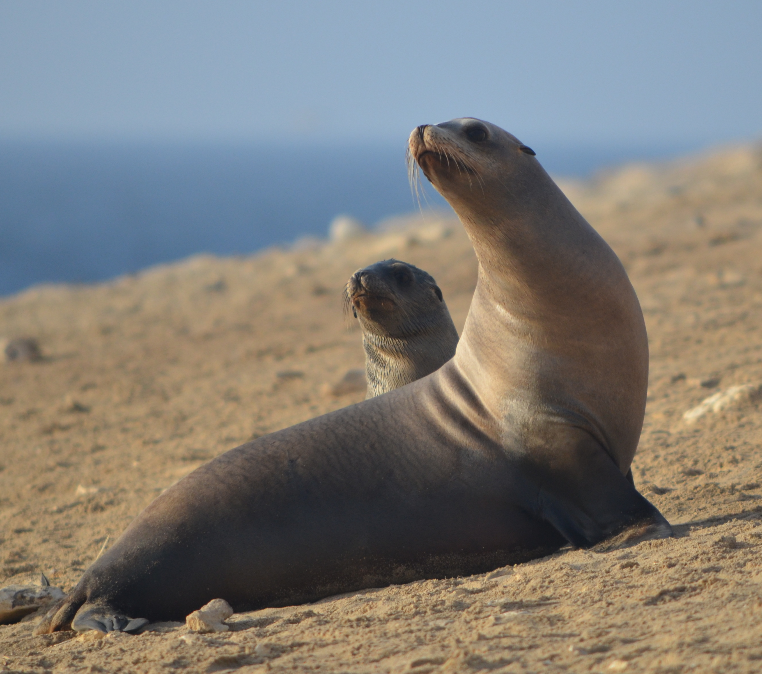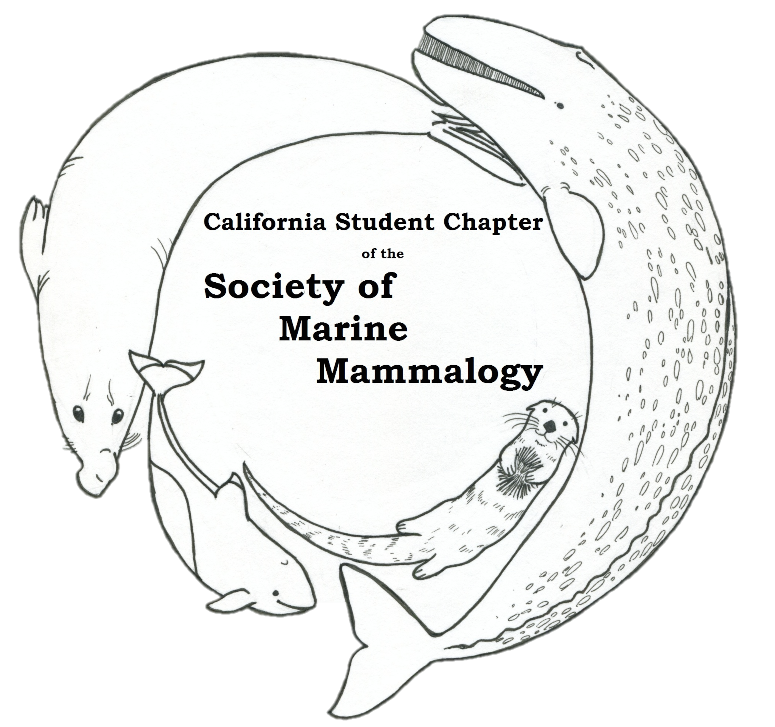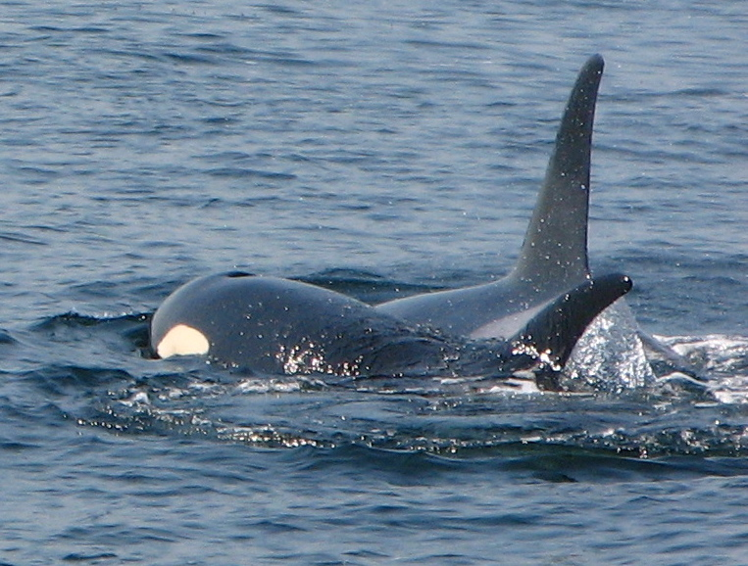

8:30 – 9:00 Registration/check-in
9:00 – 9:15 Opening remarks – Dr. Jim Harvey

9:15 – 9:30 Chris Law (UCSC) – Anvil or Jaws: Linking feeding performance & energetics to intraspecific dietary specialization
9:30 – 9:45 Kane Cunningham (UCSC) – High-frequency hearing in seals and sea lions
9:45 – 10:00 Michael Peterson (UC Berkeley) – Persistent organic pollutant accumulation in northern elephant seals
10:00 – 10:15 Max Tarjan (UCSC) – A first look at using genetics to quantify reproductive success and skew in male sea otters

10:15 – 10:30 Coffee/tea/snack break

10:30 – 10:45 Trevor Joyce (UCSD/Scripps) – Comparisons of dive behavior and habitat use within the deep-diving toothed-whale assemblage of the northern Bahamas
10:45 – 11:00 Chayo Fuentes (Alaska Pacific University) – Anthropogenic contaminants in the Elkhorn Slough: Hindrance to southern sea otter (Enhydra lutris nereis) population recovery
11:00 – 11:15 Sarah McKay Strobel (UCSC) – Skimming the surface: sensory ecology of sea otters foraging in an underwater world
11:15 – 11:30 Douglas Krause (UCSD/Scripps) – Sudden Impact: Novel hunting tactics, social interactions, and ecosystem impacts of a growing leopard seal (Hydrurga leptonyx) population at Cape Shirreff, Livingston Island

11:30 – 12:00 Plenary Speaker – Dr. Jeremy Goldbogen

12:00 – 1:00 Lunch

1:00 – 1:15 Sarah Peterson (UCSC) – They can swim but they can’t hide: elephant seals bioaccumulate contaminants in the deep ocean
1:15 – 1:30 Sarah Codde (Sonoma State) – Effects of environmental variables on skin temperature of breeding adult female northern elephant seals, Mirounga angustirostris, and pups
1:30 – 1:45 Jackie Lindsey (MLML) – Estuarine habitat use by the California sea otter (Enhydra lutris nereis)
1:45 – 2:00 Kelly Lynn Stringer (University of Pittsburg) – Increased vessel noises affecting vocalizations and behaviors of endangered southern resident killer whales
2:00 – 2:30 Coffee/tea/snack break

2:15 – 2:30 Canon Purdy (UCSD/Scripps) – How do you solve a problem like a sea lion? Exploring the complicated abundance of Zalophus californianus
2:30 – 2:45 Tristan Burgess (UC Davis) – Human development and land cover predict Toxoplasma gondii exposure in California sea otters
2:45 – 3:00 Sarah Chinn (Sonoma State) – The high cost of motherhood: end-lactation syndrome in southern sea otters (Enhydra lutris nereis)
3:00 – 3:15 Sarah Kienle (UCSC) – Biting vs. suction: Examining underwater feeding strategies in multiple pinniped species

3:15 – 3:30 Coffee/tea/snack break

3:30 – 3:45 Alicia Amerson (UCSD/Scripps) – Through Their Eyes - a whale watching study
3:45 – 4:00 Liz McHuron (UCSC) – Behavioral drivers of energetic expenditure in California sea lions
4:00 – 4:15 Michael Tift (UCSD/Scripps) – Endogenous carbon monoxide in the breath and blood of marine mammals
4:15 – 4:30 Caroline Casey (UCSC) – The voice of the northern elephant seal: signal divergence in a recovering species

4:30 – 5:00 Closing remarks – Dr. Gitte McDonald

5:00 – 7:00 BBQ at MLML, followed by optional festivities in Santa Cruz

2ND ANNUAL STUDENT CHAPTER CONFERENCE ABSTRACTS: MAY 2, 2015
MOSS LANDING MARINE LABS, CA

Chris Law (UCSC), Rita Mehta – Anvil or Jaws: Linking feeding performance & energetics to intraspecific dietary specialization
Despite the recognition that many species populations exhibit intraspecific dietary specialization, the consequences of this phenomenon on individual fitness are poorly known. Individual southern sea otters (Enhydra lutris nereis) within the central California population exhibit great specialization in diet and tool-use during feeding5. While some individuals use rocks and shells as anvils or hammers, others do not use tools yet still feed on the same hard-shelled prey. Despite the large number of studies on sea otter life history and ecological role as a keystone species6, how prey specialization and tool-use variation affects optimal foraging efficiency remains unknown. In addition, whether prey differ in their hardness and whether this limits otter feeding has not been tested. Working with the California Department of Fish and Wildlife (CDFW) and the U.S. Geological Survey (USGS), I will investigate how variation in feeding performances and the occurrence of tool use in some individuals affects dietary specialization and caloric acquisition within a population. Preliminary dissection-based modeling of 21 otters found estimated bite forces scaled with positive allometry relative to body mass, suggesting that larger otters can generate relatively larger bite forces (327 N in ♂ adult). Nevertheless, mechanical testing of some prey species found absolute rupture forces ranging from 292 to 1465 N, significantly higher than estimated bite forces. Empirical data are still needed to validate the accuracy of my estimated bite force data as well as to further understand the limitations of sea otter feeding and how tool use may provide an energetic advantage in feeding.

Kane Cunningham (UCSC), Colleen Reichmuth – High-frequency hearing in seals and sea lions
Pinniped underwater hearing abilities at frequencies near the high-frequency hearing limit are poorly understood. This is problematic given the rapid proliferation of high-frequency, high-energy acoustic marine technologies, such as commercial sonars and recreational fish finders. Misunderstandings as to which high-frequency technologies are audible to different species can lead to miscalculations of potential auditory effects. In this study, underwater detection thresholds were measured in quiet conditions in the 50-180 kHz range for one California sea lion, one spotted seal, and one harbor seal. Sensitivity curves from all three subjects exhibited two distinct slope-regions at frequencies near the high-frequency hearing limit. The first region is characterized by an initial rapid decrease in sensitivity with increasing frequency—i.e. a steep slope—and the second by a much less rapid sensitivity decrease—i.e. a shallower slope. This finding leads to the ability to detect sounds at surprisingly high-frequencies and complicates the idea of a traditional high-frequency hearing limit for these amphibious mammals. An additional masking study suggests that the initial, rapid sensitivity decrease is not due to cochlear constraints, as has been previously proposed, but may be due to constraints on the underlying bone-conduction mechanism.

Michael Peterson (UC Berkeley), Sarah Peterson, Cathy Debier, Adrian Covaci, Dan Costa – Persistent organic pollutant accumulation in northern elephant seals
Northern elephant seals (Mirounga angustirostris) travel thousands of kilometers to forage in mesopelagic (200-1000 m) regions of the North Pacific. Lengthy foraging trips interspersed with time on land make elephant seals ideal integrators of difficult-to-study oceanic ecosystems. Our study (1) measured the concentrations of persistent organic pollutants (DDTs, PCBs, and PBDEs) in adult male and female seal blubber and serum before and after their long (4-8 month) foraging trip (2011 and 2012), and (2) calculated total contaminant blubber burdens for females. Female samples were paired (N=24), whereas unique males were sampled before (N=16) or after (N=17) the foraging trip. DDTs, PCBs and PBDEs were detected in all samples, in decreasing mean concentration. Mean concentrations of ∑DDTs, ∑PCBs, and ∑PBDEs in blubber upon arrival to land from a foraging trip were twice as high for males compared with females. While contaminant concentrations decreased over the foraging trip for all seals, blubber burdens increased, indicating contaminant ingestion. Differences in male and female bioaccumulation may be due to behavioral differences in both foraging and reproduction. Our results support elephant seals as an integrator of deep-ocean contaminant exposure, and elephant seal bioaccumulation patterns may reflect threats to more cryptic marine predators.

Max Tarjan (UCSC), M. Tim Tinker, Holly Ernest – A first look at using genetics to quantify reproductive success and skew in male sea otters
In polygynous mating systems, males compete for access to females. Male quality and competitive ability therefore influence male reproductive success. Quantifying male reproductive success has been difficult in sea otters, as there is no male parental care (males are not observed with their pups) and it is relatively rare to observe copulation of known individuals. We solved the challenge of quantifying male reproductive success using newly developed genetic markers and paternity analyses. To determine paternity and estimate reproductive success, tissue samples were analyzed using microsatellite markers at 39 loci. We successfully genotyped samples from 68 males and 215 females, which were collected in Monterey Bay, CA between 1999 and 2012. Using the genetic software programs CERVUS, FRANz, and KINGROUP, 119 animals (sires, dams, and pups) were placed in a pedigree with high confidence. Paternity assignments allow for the first estimates of male reproductive skew and success with age. The resulting sea otter pedigree offers insight into behaviors and characteristics of successful males.

Trevor Joyce (UCSD/Scripps), John Durban, Diane Claridge, Lisa Ballance – Comparisons of dive behavior and habitat use within the deep-diving toothed-whale assemblage of the northern Bahamas
Cetacean body mass and its influence on oxygen storage capacity relative to utilization has been hypothesized as an important constraint on breath-hold diving limits, and consequently on the vertical ranges and ecological niches available to different species within deep-diving toothed whale (Sub-order: Ondontoceti) foraging guild. Detailed descriptions of dive behavior necessary to address this hypothesis have recently been obtained from a range of species in disparate habitats, however this study presents the first comparison encompassing the majority of deep-diving toothed whale species within a single biome. Individual records of dive behavior and spatial ranging patterns were obtained by attaching two models of minimally invasive Argos satellite-linked instruments (48-55g) to five species of free-ranging deep-diving odontocetes in the channels of the northern Bahamas. Dive depth ranges and durations, the proportion of time spent within particular depth/temperature strata, and movement tracks were recovered from two species of delphinid, melon-headed whales (Peponocephala electra, n=13) and short-finned pilot whales (Globicephala macrorhynchus, n=15), two species of ziphiid, Blainville’s beaked whales (Mesoplodon densirostris, n=12) and Cuvier’s beaked whales (Ziphius cavirostris, n=7), and the monotypic sperm whales (Physeter macrocephalus, n=27). In comparisons at the species level we found biologically significant deviations from a previously proposed positive log-linear relationship of body mass and maximum foraging dive duration. Both ziphiid species in particular exhibited foraging dives that significantly exceeded durations and depths of P. macrocephalus dives (P>0.001), despite the smaller size of both ziphiid species relative to sperm whales. However, within both the delphinids and ziphiids, the larger species, G. macrorhynchus and Z. cavirostris, exhibited significantly greater mean and maximum dive durations relative to the smaller species within their respective families. Overall deviations from the simple hypothesized relationship of body mass and dive duration primarily reflected family level differences in oxygen utilization and foraging strategies, reinforcing the need to account for the non-independence of phylogenetically related taxa in inter-specific comparisons.

Chayo Fuentes (Alaska Pacific University), M. Tim Tinker, Ben Weitzman – Anthropogenic contaminants in the Elkhorn Slough: Hindrance to southern sea otter (Enhydra lutris nereis) population recovery
The Elkhorn Slough of Moss Landing plays key roles as a watershed, carrying pesticides from local fields, and as a home for the keystone species, the southern sea otter (Enhydra lutris nereis). The objective of this study is to identify types and concentrations of anthropogenic contaminants in live Elkhorn Slough southern sea otters that might inhibit population recovery. Twenty-five southern sea otters were captured in the Elkhorn Slough. We collected blood and fat samples from each individual, attached flipper tags and, in most, implanted radio transmitters (n=20). Fifteen of the archived samples will be tested for various types of contaminants, predominantly pesticides. Some of the analytes, such as DDT and PCB, are older legacy pesticides; however, pyrethrins and pyrethroids are among the more recently pervasive pesticides. This diagnostic study will give researchers a baseline for the pollutants in the slough so that further studies can investigate the factors contributing to their profusion.

Sarah McKay Strobel (UCSC), M. Tim Tinker, Colleen Reichmuth – Skimming the surface: sensory ecology of sea otters foraging in an underwater world
At the species level, sea otters are unique in their consumption of a wide breadth of invertebrates requiring vastly different handling skills. In a food-limited environment, even slight differences in handling ability among individuals can drive prey specialization. To date, handling ability for sea otters has been quantified exclusively from time at the surface. A critical and unanswered question is how slight differences in underwater handling time—including search time, prey detection, and prey extraction—can drive specific foraging strategies. The first steps to understand how wild sea otters detect and capture their prey must include descriptions of primary sensory structures and measurements of corresponding performance in a controlled setting. New possibilities are emerging to study underwater behavior due to technological advances, a strong base of trained captive and wild rehabilitated sea otters, and enthusiastic cooperation among a variety of researchers and institutions. Building on this framework, we will use a combination of approaches, including anatomical, observational, and experimental studies of captive and wild sea otter foraging behavior. I outline our steps to understand the internal sensory and cognitive limitations of individual sea otters—and the flexibility within these limitations—that likely function as mechanistic drivers of foraging strategies, and ultimately specialization.

Douglas Krause (UCSD/Scripps), Mike Goebel, Greg Marshall, Kyler Abernathy – Sudden Impact: Novel hunting tactics, social interactions, and ecosystem impacts of a growing leopard seal (Hydrurga leptonyx) population at Cape Shirreff, Livingston Island
Leopard seals are apex predators that can alter the community structure of Antarctic coastal ecosystems. Previous behavioral studies were limited to land-based, daytime observations of foraging leopard seals. Consequently, foraging tactics, social behaviors, and indirect ecosystem impacts are poorly understood. Here we present the first analysis of animal-borne HD video footage for foraging leopard seals. Each CRITTERCAM was deployed with Fastloc GPS and time-depth-recorder instruments providing fine-scale habitat context for observed foraging behavior. We analyzed seven deployments obtained in January and February of 2013 and 2014 from adult female leopard seals near mesopredator breeding colonies on Livingston Island, Antarctica.The average deployment length was 4.80 ± 2.45 (range: 0.86 - 9.12) days, which covered a total of 16 foraging trips. Habitat use, along with 39 prey capture attempts, and 11 leopard seal social encounters were scored from 50.3 hours of video data. We obtained 3,833 post-filter GPS positions, accurate to within 70 m, and the mean dive depth was 14.84 ± 8.98 m. Leopard seal foraging focused on four prey items: Antarctic fur seals, Antarctic fur seal pups, pygoscelid penguins, and demersal notothen fishes. Ambush tactics used only by a subset of leopard seals drove high capture success rates of fur seal pups. We identified novel prey-specific foraging tactics including stalking and flushing of notothen fishes. Leopard seals have been described as generalist apex predators; however, video and movement data suggest that leopard seals employ specialized prey-specific hunting tactics. Although preliminary, our findings indicate that leopard seals can affect coastal ecosystems through pathways beyond direct predation, including intraspecific kleptoparasitism and facultative scavenging/food caching. Our results suggest that position-integrated video data will be vital in quantifying the ecological impact of this abundant and versatile apex predator.

Sarah Peterson (UCSC), Michael Peterson, Josh Ackerman, Adrian Covaci, Cathy Debier, and Dan Costa – They can swim but they can’t hide: elephant seals bioaccumulate contaminants in the deep ocean
Northern elephant seals (Mirounga angustirostris), mesopelagic (200-1000 m) marine predators that forage in the coastal and open-ocean North Pacific Ocean, integrate contaminants into their tissues while foraging. We used satellite-tracked adult females (with time-depth recorders) as biologgers of mercury and persistent organic pollutants (POPs), to examine links between foraging ecology and contaminant accumulation, as well as to determine how contaminant distribution may vary geographically. At the end of a foraging trip, we sampled 77 seals for total mercury (blood and muscle) and a subset of these (N=23) for POPs (blood and blubber). Total mercury in blood and muscle fell among the highest concentrations reported for marine predators. Moreover, foraging ecology influenced mercury exposure, with the highest concentrations observed in offshore, deep-diving females and the lowest concentrations observed in more northerly foraging females. We observed differences in mercury and some POP compounds across the foraging range of elephant seals, suggesting varying geographic distributions and bioaccumulation of specific compounds. Our results indicate that mesopelagic predators may be at greater risk for contaminant accumulation than previously assumed and provide insight into the potential for contaminants in elusive and vulnerable mesopelagic species.

Sarah Codde (Sonoma State), Sarah Allen, Dan Crocker – Effects of environmental variables on skin temperature of breeding adult female northern elephant seals, Mirounga angustirostris, and pups
Pinnipeds may come onshore for extended periods of time during the breeding season and many species retreat to the water if exposed to high ambient temperature. However, the natural behavior of adult female northern elephant seals with lactating pups is to avoid the water during this sensitive time. As California’s air temperature is predicted to increase due to climate change, elephant seals may need to adapt or suffer from hyperthermia. A colony in Point Reyes National Seashore displays this previously undescribed behavior of retreating to the water at high ambient temperatures. We used a thermographic camera to measure skin temperature of adult females and pups and will investigate the seals’ different thermoregulatory properties and behaviors at different stages of lactation. Environmental variables, such as ambient temperature and solar radiation, will be analyzed for their effect on skin temperature. Results may help predict important habitat features for areas that elephant seals might move to as their population expands and their colonies shift.

Jackie Lindsey (MLML), James Harvey, M. Tim Tinker – Estuarine habitat use by the California sea otter (Enhydra lutris nereis)
While northern sea otter (Enhydra lutris kenyoni) populations have expanded in size and range in Alaska and Washington State, southern sea otters (Enhydra lutris nereis) have failed to recover to sustainable population levels in California. None of the known threats to southern sea otters have fully explained this slow rate of population growth. One proposed indirect limitation on the growth rate is that the linear, one-dimensional shape of the California coastline limits the dispersal distances of sea otters and restricts the potential for rapid range expansion. Thus, understanding the spatial ecology of sea otters may be key to understanding the rate of recovery. I will compare 20 individual otters of different status among different habitats in Elkhorn Slough, which is the only location of otter recolonization of an estuary in California. Daily resights and telemetry locations of each individual will allow me to analyze home ranges, behavior, and habitat use within the non-linear slough environments. By understanding how sea otters are presently using an estuarine environment, I hope to understand how estuaries might be managed to encourage future sea otter re-colonizations.

Kelly Lynn Stringer (University of Pittsburg) – Increased vessel noises affecting vocalizations and behaviors of endangered southern resident killer whales
Increased vessel noises are effecting the vocalizations and behaviors of the endangered southern resident killer whales. This resident species Orcinus orca resides in the inner waterways of Washington State and the lower reaches of British Columbia. These waterways are popular recreational vessel areas as well as busy commercial shipping areas. Interest in killer whales is growing which is seen in the high number of whale watching vessels that scope out the clan. The critical habitat for the endangered species is seeing an increase in vessel activity, which, in turn, generates an increase in underwater noise. The noises create a potential for masking killer whale vocalizations disrupting their communications, like calls and echolocation, for survival. Anthropogenic noise pollution, also, creates shifts in natural behaviors to more stressed responses from southern resident killer whales. Effects on behavior and vocalizations may be detrimental to the continued survival of this endangered species. This article aims to discuss the changes in vocalizations and behaviors of a specific community of killer whales in the Northwest Pacific Ocean due to the increasing volumes of vessel traffic and noise that is disturbing the underwater habitat.

Canon Purdy (UCSD/Scripps) – How do you solve a problem like a sea lion? Exploring the complicated abundance of Zalophus californianus
Since the 1970s, the California sea lion population has been on the rise, reaching near an estimated 300,000 individuals according to NOAA stock assessments. Usually this kind of population abundance can be considered a conservation success, but with such numbers comes a copious amount of complications, especially considering that pinnied's unique biology allows them to interact with humans on land and in the sea. This talk will explore sea lion and human interactions from the perspective of two user groups; sports fishermen of San Diego, and marine mammal stranding volunteers up and down the California coast. Through their stories, we will explore different the management options available when we face the question; How much success is too much?

Tristan Burgess (UC Davis), M. Tim Tinker, Melissa Miller, Woutrina Smith, Patricia Conrad, Christine Johnson – Human development and land cover predict Toxoplasma gondii exposure in California sea otters
Protozoal meningoencephalitis, caused by Toxoplasma gondii and Sarcocystis neurona, represents a significant cause of mortality for reproductive-aged sea otters. Individual and behavioral risk factors for T. gondii exposure include male sex, and diet preferences including a high percentage of kelp snails. The only known definitive hosts shedding infectious oocysts are terrestrial felids, but despite this, little is known about features of the terrestrial environment that determine risk of pathogen transfer into the marine environment. In this study we present a novel method for evaluating the relationship between landscape-based features and disease exposure risk. We conducted a spatially-weighted regression using a weighting index calculated from discharge of each river within the study area and distances between capture location and river outflows. Distances were calculated based on real-world coastal topography to reflect the distance an otter must swim between two points. This index was used to weight exposure of each study animal to indices of development and land-cover, calculated for coastal watersheds adjacent to the entire sea otter range in California as well as comparison sites in Washington and Alaska. While a simple comparison of the features of the study sites with seroprevalence indicated a positive association with some land-cover categories (cropping - spearman’s ρ= 0.9, p = 0.0001; pasture - ρ= 0.72, p = 0.01), weighted regression analysis found these factors to be less accurate predictors of serum antibody status than human housing unit density. A 2-fold increase in housing density in adjacent watersheds was associated with a 1.3-fold increase in disease exposure odds among sea otters (p<0.0001). We conclude that specific features of areas of denser human habitation are conducive to greater oocyst loading or mobilization into freshwater. This effect may be driven by increased definitive host abundance in areas of human habitation or altered watershed permeability.

Sarah Chinn (Sonoma State), Melissa Miller, M. Tim Tinker, Michelle Staedler, Francesca Batac, Laird Henkel – The high cost of motherhood: end-lactation syndrome in southern sea otters (Enhydra lutris nereis)
With a resting metabolic rate ≥2 times higher than similar terrestrial and marine mammals, sea otters (Enhydra lutris) live continuously outside of their metabolic thermal-neutral zone. This evolutionary strategy necessitates near-constant energy procurement and consumption of 20-25% of body mass in prey daily to maintain homeostasis. These requirements nearly double during pup care, making adult females vulnerable to caloric insufficiency. Female sea otters appear to optimize reproductive success and survival through nutritional “front-loading” during delayed implantation and gestation. However, the metabolic challenge of reproduction culminates in numerous maternal deaths annually due to massive depletion of energy reserves. Called end-lactation syndrome (ELS), this condition is one of the most common causes of mortality for adult female southern sea otters (E. lutris nereis). Findings supportive of a diagnosis of ELS were moderate to severe emaciation that was not attributable to a concurrent, unrelated disease process in females dying during late pup care or early post-weaning. Our study characterizes and defines ELS, examines risk factors, and highlights strategies used to optimize reproductive success. For 108 reproductively active females necropsied from 2005-2012, 56% had ELS as a primary or major contributing cause of death. Peak ELS prevalence occurred in late spring, possibly reflective of fall/winter pupping attempts, or rapid reproductive recycling for females that had experienced pup loss. Increasing age and number of pregnancies were associated with a higher risk of ELS, possibly reflecting the high and cumulative metabolic cost of maternal care. Although the proportion of ELS females was highest in coastal areas with dense sea otter populations, cases were recovered throughout the range, suggesting that death from ELS may not be solely associated with prey resource limitation. Any condition that impairs individual fitness and foraging efficiency, including infection, cognitive defects or trauma, could enhance the risk of ELS expression in reproductively active females.

Sarah Kienle (UCSC), Holly Sorensen, Rita Mehta, Colleen Reichmuth – Biting vs. suction: Examining underwater feeding strategies in multiple pinniped species
Pinnipeds are apex predators in marine ecosystems, yet we understand little about how these animals capture and consume prey underwater. Pinnipeds are carnivores, and, like their terrestrial relatives, many are raptorial biters that use small, sharp teeth to capture and swallow prey. However, most aquatic species, including pinnipeds, are also capable of using some amount of suction underwater. Some pinnipeds (e.g., walrus, bearded seal) have evolved more specialized forms of suction that they use to consume prey. For most pinnipeds, our knowledge of their feeding strategies and behaviors comes from indirect evidence (e.g., morphology, satellite tracks, diet composition study). The objectives of this study were to determine the feeding behaviors of multiple pinniped species, specifically spotted seals, ringed seals, and California sea lions, and 2) investigate feeding performance in these species, especially related to suction and biting. We conducted ~50 controlled feeding trials per individual using whole prey (capelin and herring). Feeding trials were conducted with a feeding apparatus designed so that animals could consume prey using suction and/or biting. Each feeding trial was filmed in an anterior and lateral view with GoPro videos recording at 60 frames per second. Our preliminary results show that all species tested are capable of using both biting and suction underwater. Some individuals used both biting and suction during a single feeding event. Prey size may determine whether animals choose to use suction or biting, and future work will include prey of multiple sizes to investigate this further.

Alicia Amerson (UCSD/Scripps) – Through Their Eyes - a whale watching study
Through Their Eyes is a study to identify best practices for sustainable and responsible whalewatching along the Pacific coast. The motivation to understand how operators protect whales and educate tourists is reflective in minimizing current anthropogenic impacts to whale populations worldwide for future generations. The study will obtain data through field observations and distribution of an online survey. This study will conclude in May, 2015. Results will be presented at Scripps Institution of Oceanography Center of Marine Biodiversity and Conservation Symposium in June, 2015. Results shared with whale watching operators and project collaborators such as NOAA, The Whaleman Foundation, and IWC Whalewatching committee are projected to increase awareness for enhancing whalewatching as a platform for increased protection for cetaceans.

Liz McHuron (UCSC), Luis Huckstadt, Sarah Peterson, Daniel Costa – Behavioral drivers of energetic expenditure in California sea lions
Environmental changes that affect prey availability and distribution influence predator behavior and may alter energetic budgets of marine mammals. Here we present data on the relationship between energetic expenditure and at-sea behavior in California sea lions (Zalophus californianus), a species that inhabits a dynamic ecosystem and exhibits flexibility in foraging behavior. Adult females were instrumented with satellite tags and time-depth recorders at San Nicolas and San Miguel Islands in southern California (n = 15). We concurrently measured field metabolic rates (FMR) using the doubly labeled water technique across at least one foraging trip to sea, and determined whether there were any relationships between behavioral variables and at-sea FMR. At-sea FMRs ranged from 4.1 – 8.2 W/kg, which spans the range of FMRs observed for most otariid species. The top model contained only one variable, the intra-depth zone index (IDZ), which explained over 70% of the variability in at-sea FMR. The IDZ is a measure of whether successive dive depths are within 10% of each other, and is an indirect measure of benthic foraging. There was a positive correlation between the IDZ and bottom time (r = 0.68), which is consistent with a typical benthic diving pattern. Overall, these results indicate that benthic diving, and potentially other behaviors that increase bottom time, is an energetically expensive behavior for California sea lions. This has implications for energetic tradeoffs associated with different foraging strategies and should be considered in assessing environmental changes may impact the reproductive fitness of this species.

Michael Tift (UCSD/Scripps), Judy St. Leger, Paul Ponganis – Endogenous carbon monoxide in the breath and blood of marine mammals
Carbon monoxide (CO) is known by many to be toxic and solely produced from the incomplete combustion of fuel. However, CO is also a natural by-product of heme degradation, and certain levels have shown to be protective against inflammation and cell death associated with ischemia-reperfusion injuries. Elevated endogenous CO in two deep-diving seal species suggest that these natural increases are secondary to the metabolic turnover of their high heme contents. And despite reductions in oxygen storage capacity, such concentrations may be beneficial in prevention of possible ischemic injury associated with the dive response during deep dives. To investigate if CO is elevated secondary to heme content and heme degradation in marine mammals, we compared levels of CO in the breath and blood to concentrations of hemoglobin, bilirubin and heme in the blood of four cetacean species with distinct dive capacities and heme contents (bottlenose dolphins, killer whales, Pacific short-finned pilot whales and beluga whales). Human smokers and non-smokers and the northern elephant seal (containing the largest mammalian heme stores) are used as reference values. End-tidal carbon monoxide (ETCO) levels were variable in cetaceans but reflected heme content with the highest concentrations in beluga whales (10 ppm), the species with the highest hemoglobin concentration and mass specific blood volume. The beluga whale ETCO values were less than those of the northern elephant seal (~20 ppm), but were comparable to levels in human smokers (> 6ppm). This study confirms that end tidal carbon monoxide concentrations in these cetaceans are proportional to total heme content and supports the hypothesis that these elevations in carbon monoxide are secondary to heme metabolism in marine mammals.

Caroline Casey (UCSC), Colleen Reichmuth, Dan Costa – The voice of the northern elephant seal: signal divergence in a recovering species
While we typically refer to behavioral patterns at the population level, each population comprises unique individuals that often exhibit differences in behavior. If this behavioral variation is heritable, it likely provides material for natural selection, and can lead to significant ecological implications. Acoustic signaling is fundamental to animal social systems, and supports breeding, foraging, and parental care. Although acoustic variation among individuals is widespread across taxonomic groups, our ability to determine what factors drive this divergence remains limited. The northern elephant seal, presents an exceptional opportunity to document how male vocal displays have changed over the course of population recovery from near extinction. Since ecological, demographic, and genetic data have been collected during their recovery, they provide a model system to understand how these processes may contribute to variation in acoustic behavior. To characterize the current call patterns specific to various breeding colonies and contrast these to those almost half a century ago, we recorded and quantified the variation present in male northern elephant seal vocalizations at seven breeding colonies across their geographic range. The results reveal significant differences between the level of inter-individual variation present in the calls of male seals in 1969-1971, and those recorded from 2013-2015. Consistent with previously published work, the historical recordings were nearly homogeneous within each breeding site, and consisted of simple, impulsive units emitted at regular rates. In contrast, the current populations of males exhibit a dramatic increase in vocal diversity, with higher levels of inter-individual variation within and across all sampled locations. Calls also showed greater structural and temporal complexity. We plan to incorporate these data along with well-documented patterns of habitat use, genetic diversity, and demographic variation into a refined framework to evaluate the processes that may drive the observed signal divergence in the calls produced by male northern elephant seals.

